

**DEDAN KIMATHI UNIVERSITY OF TECHNOLOGY**

**INSTITUTE OF GEOMATICS, GIS AND REMOTE SENSING (IGGReS)**

**GIS BASED UTILITY MONITORING SYSTEM FOR OPTIC FIBER CABLES**

**CASE STUDY OF WESTLANDS**

**BY**

**BENJAMIN MBITHI KIIO**

**E032-01-0912/2014**

# ABSTRACT

Fiber optic technology is a revolutionary technological departure from the traditional copper wires twisted-pair cable or coaxial cable. It is a very crucial and essential communication medium in the development of a nation. Therefore, the design, deployment and management of fiber optic cable components should be monitored and maintained efficiently to avoid long hours of communication disruption in case of network outages. The study presents the use of Geographic Information Systems in management of fiber optic cable distribution network for service providers. The components of the distribution network which will be considered is that of telecom network, Kenya data network and safaricom network because the study is limited within Westland, Nairobi Kenya. The telecom network features include digital cross connect, digital loop carrier, fiber cable, fiber interconnect, multiplexer, optical repeater, patch panel, splice closure, splitter, telecom network junction and termination.

A digital map showing fiber optic cable distribution network in the area of study will be created by overlaying different maps. Also a spatial database will be created for storing information pertaining fiber optic cable network. Network analysis will be used to perform fiber trace to show routes of data communication flow between a transmitting and receiving network terminal points.

# Table of contents (Moses Maina)

ABSTRACT 2

Table of contents (Moses Maina) 3

CHAPTER 1: INTRODUCTION 5

1.1 Background 5

1.2 Problem statement 5

1.3 General Objective 5

1.4 specific Objectives 5

1.4 Justification 6

1.5 Scope of work 6

1.5.1 STUDY AREA 7

CHAPTER 2: LITERATURE REVIEW 8

2.1 FIBRE OPTIC CABLES TECHNOLOGY 8

2.1.1 History of fibre optics in Kenya 8

2.2 GIS IN NETWORKING PLANNING 9

CHAPTER 3: METHODOLOGY 10

3.1 Data collection 10

3.2 Data processing and Network Analysis 10

3.3 System Development 10

3.3.1 Database design 10

3.3.2 Application development 10

3.3.3 Web development. 10

3.4 System Implementation 10

3.4 Data Requirements and Tools 12

3.4.1 Hardware 12

3.4.2 Data required 12

3.4.3Data requirement table 12

3.4.4Soft wares to be used 12

3.5 Work plan 13

3.6 Budget 13

3.7. Expected Results 14

3.8. References 14

# CHAPTER 1: INTRODUCTION

## 1.1 Background

Managing a network involves more than keeping track of thousands of fiber cables and network elements stretched across hundreds of miles serving millions of customer locations. Maintaining network performance and efficiency as well as reducing costs can be a major challenge because it requires sharing information that is not necessarily kept in a shared resource. Geographic Information Systems (GIS) has a wide spread application in many of the business processes. An emerging area of interest is the fiber optic cable technology, which is amongst the fields of telecommunication industry. To support management, the fiber optic cable routes and components has to be precisely captured and stored in GIS database. GIS is also used as a network inventory and infrastructure management tool in fiber optic cable networks.

## 1.2 Problem statement

The advent of fibre optic technology in Kenya has led to a remarkable development in the country’s Information Communication Technology sector. The service providers have since then been in completion with each other in securing subscribing customers connectivity in most urban centers in the country, connecting telecommunication firm, banks, government and private working offices , homes and learning institutions. This has resulted into massive and frequent digging up of trenches along roads, pavements and even across some roads.

The manner in which fibre optic cables are laid without minding about whatever is already laying beneath the trenches being dug causes a lot of interference with other communication lines and cables already laid underground, and often leads to their damage. Pipes carrying water, fuel and sewer can also be broken in the process. They also interfere with the drainpipes and underground power and communication lines whenever they dig up the ground to repair faults detected along the cables

## 1.3 General Objective

Development of a web-based optical fiber management system that will make geographical data on optical fiber as a utility valuable to the public or specific end-users also it will be used by the network service providers and public with relative ease for spatial query, visualization, efficient updating and processing cable network records.

## 1.4 specific Objectives

* To digitally map optical cable networks in westland(Nairobi county) coupled with digital management support of a GIS.
* To perform spatial analysis that aids in quicker and accurate decision making
* To develop a web system that serve as a catalyst for the deployment of affordable access to fiber optic network infrastructure that is needed to create economic and educational opportunities for citizens and businesses.
* Precise location of Optical cables in relation to other utilities to ease intense competition for the finite space that utility facilities must occupy on road or other reserves.

## 1.4 Justification

* Optical fibre is currently being installed in many parts of the country.
* Need for an effective monitoring system that locates fibre network, efficient means of updating, retrieval and storage of records is vital to such process.
* Many people believe that investment in fiber-optic telecommunication infrastructure as a public utility will give them a competitive advantage, enabling high-tech economic development.
* Need to involve the public in such a project.

## 1.5 Scope of work

Westlands is a constituency of Nairobi County covering an area of 72.4km2  with a population 0f 176,689(census 2009).Westlands lies 01026’83’’S and 36081’11’’E.It’s located approximately 3.1km by road northwest of Central Business District of Nairobi.

This study is intended to demonstrate the use of GIS in designing fibre optic network management system. The study is limited to the fibre optic cable network only even as much as the management system network design can as well be used for the other communication lines like underground electric cabling which might have the same challenges ,the study also is limited to area of study westlands.

### 1.5.1 STUDY AREA

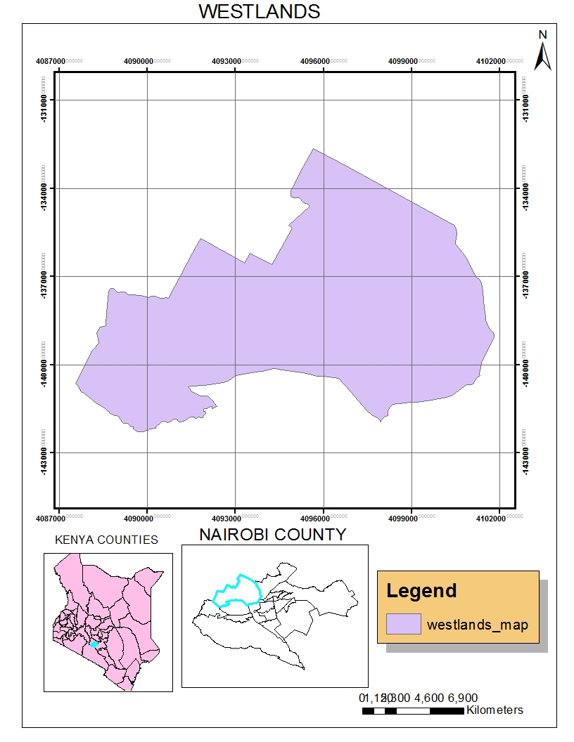

Figure1.0

# CHAPTER 2: LITERATURE REVIEW

## 2.1 FIBRE OPTIC CABLES TECHNOLOGY

### 2.1.1 History of fibre optics in Kenya

In the year 2002, the East Africa Business Community started a process that would see countries collaborate to bring fibre connectivity to the entire region. Building a submarine cable on the Eastern Africa seaboard was part of the plan but delays and shareholder disagreements compelled Kenya to opt for its own cable. The East African Marine System (TEAM) was launched as the contingency to guarantee connectivity in the shortest time possible. Connecting Kenya to a hub in Fujairah, United Arab Emirates the project brought together players from private sector and government and was completed in record time. It became the first cable to land in Kenya in June 2009(Soft Kenya, 2014).

It was followed by SEACOM, a privately funded and more than three-quarter African-owned fibre link that aims to help communication carriers in South and East Africa. SEACOM provide links between South Africa, Kenya and the world via fibre networks that pass through India and Europe, (soft Kenya, 2014)

The East African Submarine System (EASSY) fibre optic link landed in March 2010. Undersea fibre optic cable systems provides African retail carriers with equal and open access to inexpensive bandwidth, removing the international infrastructure bottleneck and supporting East and Southern African economic growth. One megabyte of bandwidth on satellite costs about 3,000 US Dollars and operators anticipate prices to be as low as 500 US Dollars. Such dramatic drops in rates will boost adoption and use in business, government and households, which are constrained by high cost for relatively low speeds.

All forms of commerce will benefit from fibre optic connectivity as it will lower the cost of communication, which I vital part of any business. New opportunities will emerge for the growth of the data market as cheaper bandwidth should translate to more users.

Many sectors have invested in this sector recently, including the public and private sectors, which have continued to invest in roll-out and expansion of broadband infrastructure in an effort to ensure access to high speed data communications services by all forms of clients

In addition to the South African East Submarine cable system, the East African Marine cable system and the East African Submarine System which have already landed at Kenya’s coast, several more international links are expected to grace the Kenyan shores, increasing competition and allowing for more link availability.

Telkom Kenya, Kenya Data Networks, Access Kenya, Wananchi and Jamii Telecom embarked on laying out fibre-optic networks terrestrially across the country. The extensive networking being undertaken by private developers has seen the number of houses who can access fibre optic internet links rise from a few hundred in 2009 to an estimated seven million homes (soft Kenya, 2014). The government has also invested in national fibre optic network that will take fibre deeper into rural areas that may not initially be considered commercial priorities by commercial enterprise.

An area where GIS has become particularly important is in cellular network planning. In the last few decades revenues from mobile telecom markets have risen exponentially. Numerous new companies have entered the field, each vying for a portion of market. This market expansion has been particularly great in countries with poor cable telephone networks. Mobile telephone companies use radio propagation model to find the best sites for building transmission stations. The models show engineers the sorts of terrain and obstacles that a radio signal would have to contend with. This is because companies need to identify sites that are higher than surrounding areas and away from buildings or any other major physical obstruction that might interfere with the signals.

## 2.2 GIS IN NETWORKING PLANNING

In most developed parts of the world, the degree of change to external plant networks has been substantial; with fibre optic cables replacing copper wire, and microwave or satellite is replacing fixed, long distance landlines. GIS has been used to determine the most suitable method of transmission between wireless and cable, it has also been used to plan network layouts and target customers. Topography, population density and predicted population trends are important considerations when considering transmission method, while detailed demographic including information, employment, affluence and neighborhood characteristics, help telecommunication providers to assess the best potential areas for the customers.

Optical fibre relay system

A fibre optic relay system consists of the following four components; the transmitter, the optical fibre generator and the optical receiver. The transmitter produces and encodes the light signals. It is physically close to the optical fibre and may have a lens to focus the light into the fibre. The optical fibre is the conductor of the light signal over distances. The one or are optical generators are spliced along the cables to boost the light signal for long distances. The voids signal loss that occurs especially when light is transmitted over long distances. The optical receiver then receives the incoming digital light signals and decodes them and sends the electrical signal to the recipient user’s computer, television or telephone. The receiver uses a photocell or photodiode to detect the light.

# CHAPTER 3: METHODOLOGY

## 3.1 Data collection

* Topographical map of Nairobi County which is the Base map, will be acquired from Survey of Kenya at scale of 1:2500
* Fibre Network (safaricom, telecom and Kenya Data Network).
* GPS coordinates of supermarkets, petrol station, government offices and intuitions like colleges and universities
* Road data, rivers.

## 3.2 Data processing and Network Analysis

## 3.3 System Development

### 3.3.1 Database design

To use postgreSQL software to create a postGIS database to handle data having a spatial elements. The database is to be connected to the layers created in Quantum GIS.

### 3.3.2 Application development

To design and create an application that is to be used in the optical fibre management system. Map files created in ArcGIS will form the base map. By linking these files to map server software and coding using PHP scripts and Java scripts functionality will be added to the application.

### 3.3.3 Web development.

To create a graphical user interface for the system. The web pages will be created using PHP scripts, html and Macromedia Dreamweaver software

## 3.4 System Implementation

**FLOW CHART**

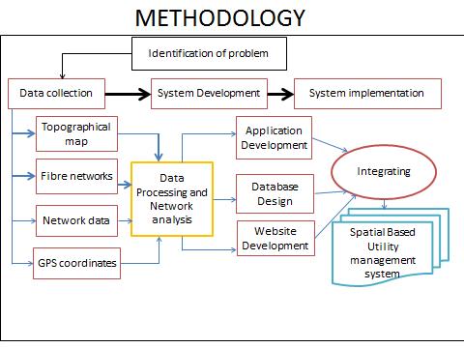

Figure 1.1

## 3.4 Data Requirements and Tools

### 3.4.1 Hardware

Laptop (HP ENVY14, hdd-500GB,RAM-6GB,processor-2.67Ghz)

### 3.4.2 Data required

* Topographical map (base map)
* Fibre networks ( already existing fibre optic cables in the area of study ie Kenya Data Networks, telecom networks and safaricom)
* Communication network data( Road network, rivers)
* GPS data( supermarkets/shopping malls, petrol stations, government offices, health facilities, recreational areas

### 3.4.3Data requirement table

|  |  |  |
| --- | --- | --- |
| Name of the data | Format | Source of the data |
| Topographical map (base map) | Map file | Survey of Kenya |
| Fibre network (KDN) | Shape file | Telecom liquid |
| Roads network | Shape file | KeRRA |
| GPS data | Points | Hand picking /Google Earth |
|  |  |  |
|  |  |  |

### 3.4.4Soft wares to be used

* ArcGIS 10.3.1- to create the digital map and link to the database
* Dreamweaver – to write the scripts used in the system
* Map server for windows- act as a server on local host
* PostgreSQL- to create database

## 3.5 Work plan

|  |  |  |  |  |  |  |  |  |  |  |  |  |  |  |  |  |  |  |  |
| --- | --- | --- | --- | --- | --- | --- | --- | --- | --- | --- | --- | --- | --- | --- | --- | --- | --- | --- | --- |
| Month | MAY/JUNE | | | | | JULY/AUG | | | | SEPT/OCT | | | | | NOV/DEC | | | | |
| Activities /week |  | | | | |  | | | |  | | | | |  | | | | |
| Preparation of proposal and presentation |  | | |  | |  | | | |  | |  | |  |  | | | | |
| Consulting supervisor |  | |  | | |  |  | |  |  | |  | |  |  | |  | |  |
| Data collection |  | | | | |  | | | |  | | | | |  | | | | |
| Data processing and analysis |  |  | | |  |  |  | |  |  | | | | |  | | | | |
| Coding |  | |  | | |  | | | |  | | | | |  | |  | |  |
| Progress presentation |  | | | | |  | |  | |  |  | |  | |  | | | | |
| Final presentation |  | | | | |  | | | |  | | | | |  |  | |  | |

## 3.6 Budget

|  |  |
| --- | --- |
| Activity | Amount (ksh) |
|  |  |
| Transport | 5000 |
| Internet bundles | 2000 |
| Totals | 7000 |

## 3.7. Expected Results

* It is expected that the web-based optical fibre monitoring system developed will link with the database and offer spatial information to anyone who access it via internet.
* Easier location of optical cables in relation to other utilities like pipelines, sewer
* A digital map showing optical cable networks in westlands in Nairobi County.

## 3.8. References

(n.d.). Retrieved from how does fibre optics work? explain that stuff: http://www.explainthatstuff.com/fibreoptics.html

Moses Maina, M. G. (n.d.). A Geospatial Information System Based Fibre Optic Cable Infrastructure Management Database for Nairobi West-District Kenya. *International journal of Sciences Basic and Applied Research* , 12.

*Soft Kenya* . (n.d.). Retrieved from Fibre optic in Kenya /softKenya.com: http://softkenya.com/kenya/fibre_optic_in_kenya/

*TEAMS( cable system)*. (n.d.). Retrieved from http://TEAMS_(cable system)